Non-Fiction:
Overview

We will be examining the use of rhetoric this year as well.
As you read these historical speeches, keep the rhetorical pyramid in mind:
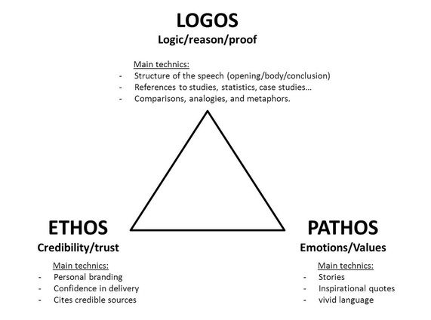

You may also use the SIFT method here but you must also consider the following:
- Who is the speaker?
- Who is the audience? What is that demographic?
- What is the setting? What is the purpose of the speech?
- What goal(s) does the speaker have?
- What arguments does he make? How does he support those arguments?
- What examples (and what type of examples – see the triangle!) does he use?
- What is the tone? Does the tone shift at all?
- What rhetorical / literary devices does the speaker use (i.e., similes, metaphors, alliteration, symbolism, irony, etc.)?

Also, what are your personal impressions of this speech? Don’t discount your reaction! (And don’t go online to find someone else’s either!).
As with the fiction, we will discuss these in class so I want your ideas.

