Miss Arney
English 9 Honors/pre-AP
TABLE OF CONTENTS
Overview
Letter/ explanation of activities 1
Requirements for Hamilton’s Mythology 2
Olympians: chart to know by first day of classes 5
“How & Why to Annotate a book" 7
Fiction
Overview 9
“Ordeal by Cheque” by Wurther Crue 11
“The Most Dangerous Game” by Richard Connell 15
“The Test” by Angelica Gibbs 31
“The Necklace” by guy de Maupassant 35
“The scarlet ibis” by james hurst 41
“the cask of amontillado” by edgar allan poe 47
Non-ficton
overview 53
pericles’ funeral oration 55
“i have a dream” by Dr. Martin Luther King Jr. 59
Franklin Delano Roosevelt’s 1st inaugural address 63
Poetry
overview 67
“The Transformation of Arachne into a spider” by ovid 69
Poetry Cluster A: Mythological Poems
“Prometheus” by Marin Sorescu 75
“Landscape with the fall of icarus” by william carlos williams 75
“daphne” by edna st. vincent millay 75
“orpheus” by william shakespeare 76
“eurydice to orpheus” by robert browning 76

Poetry Cluster b: Assorted
“sympathy” by paul dunbar 77
“we wear the mask” by paul dunbar 77
“i look at the world” by langston hughes 77
“i, too” by langston hughes 78
“forgive my guilt” by robert tristam coffin 79
“if” by rudyard kipling 80

Miss Arney’s

English 9 Honors / Pre-AP

Summer Reading Materials
Fiction:
Overview

This year we will be applying the SIFT method of analyzing literature:

Symbol: examine the title and text for symbolism
Images: identify images and sensory details
Figures of speech: analyze figurative language and other devices
Tone, Title, and Theme: discuss how all devices reveal tone and theme; of what significance is the title of this story?

Use this method as you read each of the pieces in this packet, particularly the short fiction and poetry.

For “Ordeal by Cheque” you will be tempted to Google an explanation of the story. Resist this temptation. There is no correct “answer”, no one correct interpretation. I look forward to a lively discussion in the first weeks of school as we discuss your varied opinions of this very interesting tale.

Keep track of characters, setting, plot…all the basics; however, also delve deeper. If you notice a particularly wonderful simile, mark it; a passage looks like it may have deeper meaning? Make note of it. Even if you don’t know why it’s important, make note that it seems like it is meaningful or significant.
Look for literary elements as well as figurative devices…and think about how the author uses these devices to convey his story.

Do not look on-line for other people’s summaries or analyses. That will not help you build your skills…and, if I find out, will hurt your grade. Be confident in your own abilities; do not use grade savers.

Some of the stories, particularly “The Necklace” and “Cask of Amontillado”, have very challenging vocabulary. Try to build your skills by first determining a possible meaning based on context clues and then by comparing your definition to one in a dictionary. You may wish to put the definition in the margin or keep separate notes.

Speaking of notes, feel free to take notes any way you like. Post its? Fine. A notebook? Great! Make it something that works for you.

Non-Fiction:
Overview

We will be examining the use of rhetoric this year as well.
As you read these historical speeches, keep the rhetorical pyramid in mind:
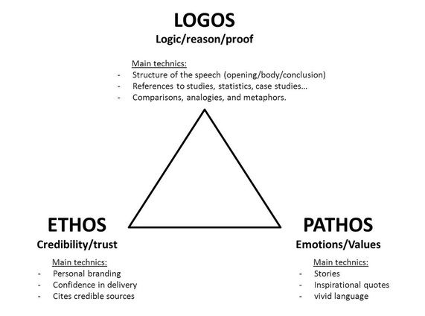

You may also use the SIFT method here but you must also consider the following:
- Who is the speaker?
- Who is the audience? What is that demographic?
- What is the setting? What is the purpose of the speech?
- What goal(s) does the speaker have?
- What arguments does he make? How does he support those arguments?
- What examples (and what type of examples – see the triangle!) does he use?
- What is the tone? Does the tone shift at all?
- What rhetorical / literary devices does the speaker use (i.e., similes, metaphors, alliteration, symbolism, irony, etc.)?

Also, what are your personal impressions of this speech? Don’t discount your reaction! (And don’t go online to find someone else’s either!).
As with the fiction, we will discuss these in class so I want your ideas.

Poetry:
Overview

Again, use the SIFT method to annotate your poems.:

Symbol: examine the title and text for symbolism
Images: identify images and sensory details
Figures of speech: analyze figurative language and other devices
Tone, Title, and Theme: discuss how all devices reveal tone and theme; of what significance is the title of this story?

Do not read Group/Cluster A (mythological poems) until you have finished reading the portions of Hamilton’s Mythology that have been assigned to you.
Then, try to see how the poems help you understand the characters and stories on a deeper level.

You may see some connections among a few poems in Group/Cluster B, but some do not have any. Read, analyze, and enjoy them.

I would also suggest reading Hamilton’s summary of the Arachne story before you read the poem.

